Provides an overview of sources you explored while researching a particular topic. Used to ensure completeness in your understanding of your research area and to demonstrate to your audience how your research fits within a larger field of study.

1. Look for existing surveys on the topic of your research
2. Identify key papers on the topic (GoogleScholor search) and preform snowballing – check all papers they reference and all papers that reference them.

Top conferences and journals in our area:

- SE: ICSE, FSE, ASE, ISSTA, TSE, TOSEM, Journal of Empirical Software Engineering

- SE Topical Conferences: ICST, ICSME, ICPC, SANER, …

Security: CCS, S&P, Usinex Security

ML: NeurIPS, ICML,…

ML Topical: FAT\*, FAT-ML,

CORE Ranking for Conferences (Pick A\* or A): <http://portal.core.edu.au/conf-ranks/>

CORE Ranking for Journals (Pick A\* or A):

<http://portal.core.edu.au/jnl-ranks/>

Google Scholar ranking of Software and Systems Area: <https://scholar.google.ca/citations?view_op=top_venues&hl=en&vq=eng_softwaresystems>

Journals ranking based on Journal Citation Report (JCR) can be found via UBC library website.

1: Go to <https://www.library.ubc.ca> and search for JCR



2: Click on Journal Citation Reports link

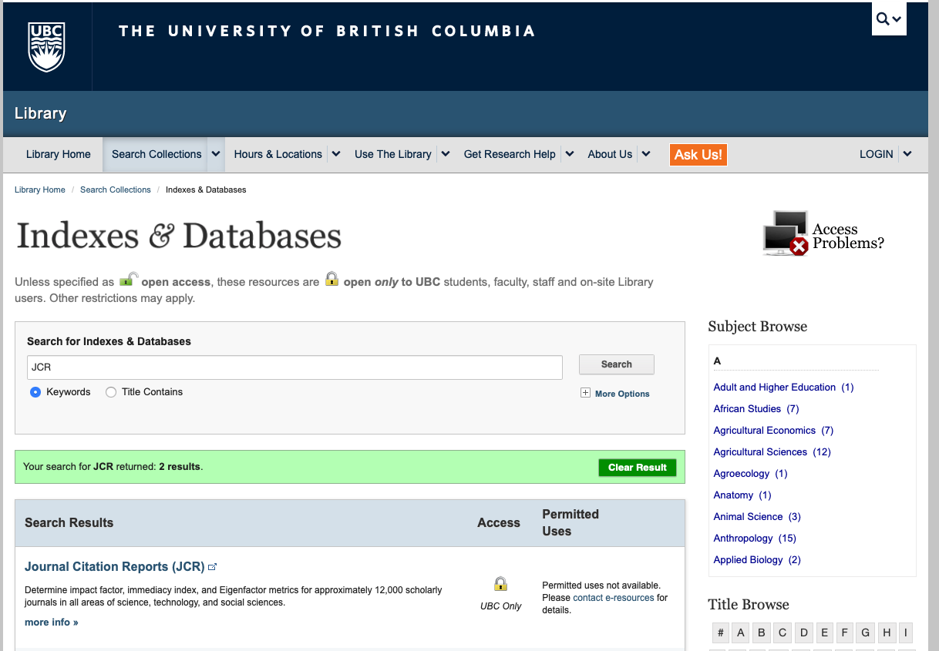

3. Search by a keyword or use advanced search methods (i.e. Browse by Journal, Category, and Custom Reports).



1. Systematic Literature Review

Several guides can be found online, e.g.,

* + Guidelines for performing Systematic Literature Reviews in Software Engineering. Barbara Kitchenham and Stuart Charters. EBSE 2007-001. Keele University and Durham University Joint Report, (2007): <http://www.cs.ecu.edu/gudivada/research/papers/guidelines-for-se-literature-reviews-summary.pdf>
  + Guidance on Conducting a Systematic Literature Review. Yu Xiao, Maria Watson. ACSP: <https://journals.sagepub.com/doi/full/10.1177/0739456X17723971>
  + Methods for Literature Reviews. Guy Paré and Spyros Kitsiou. Handbook of eHealth Evaluation: An Evidence-based Approach: <https://www.ncbi.nlm.nih.gov/books/NBK481583/>